Zirui Jiao & Qinyi Li

1. The Big Idea:

The main idea of the project is to develop a product that beat their phone addiction and manage their time in an efficient and pleasant way. We want students, officers and any group of people that procrastinate their work to eliminate time-wasting on the distracting websites. It is very similar to the popular app “forest”, however, we want to establish our project on the website. The project wishes to achieve the goal of both blocking the websites and keeping track of working time. We will explore topics such as time countdown, website blocking, the database for users, data interpretation and demonstration. The minimum viable product will be a local program in python that combines website blocking and a timer. The stretch goal would be building the project on a website, generate users’ weekly productivity, connecting friends on the website and encouraging competition in the social group.

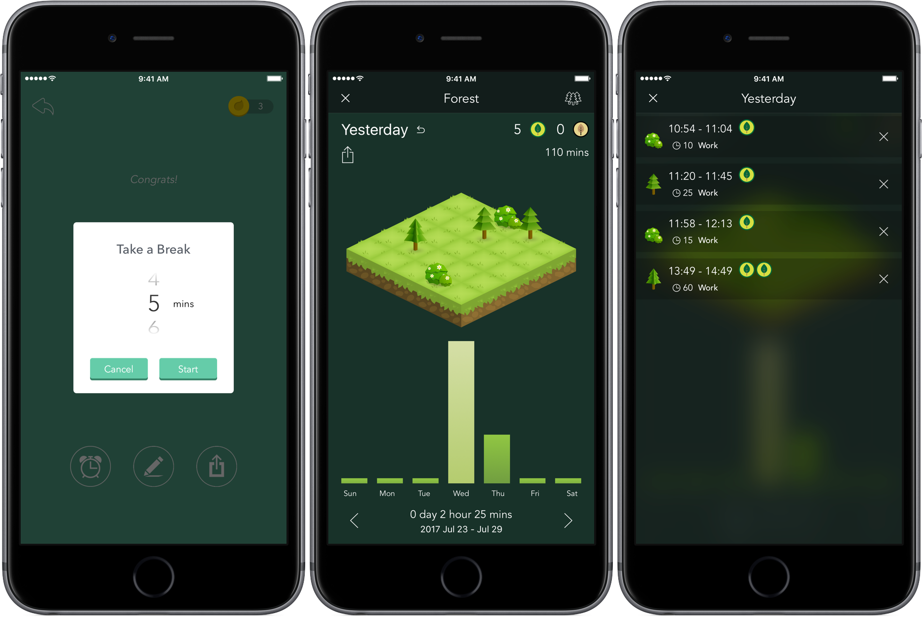

*The demonstration of “forest” app.*

2. Learning Goals:

The learning goals will be implementing an agile development process, researching code computation, seeking help from professionals and developing more python skills beyond the classroom. Also, we want to use this project as an opportunity to explore how computation can be applied to a real-world problem and make a positive influence on people’s productivity. We may also learn to arrange time effectively, finish tasks on time, corporate within the group, and develop interests further.

3. Implementation Plan:

From conversations with the professor, we learned Flask will be helpful for our project. Also, we want to research on the “forest” app to see their works. As we move further on the code computation, more problems will occur, and we will seek help from professionals. There are coding resources about timers, website block, and database building, the task is to connect them together.

4. Project schedule:

|  |  |
| --- | --- |
| Weeks | Schedule |
| 1  10/14-21 | Meet with the professor and talk about the big idea. Finish project proposal and corporate schedule with teammates. Start the initial stage: block some popular distracting websites. |
| 2  10/21-28 | Start code with time countdown, connect the timer with forbidden websites. |
| 3  10/28-11/4 | Start code with user sign-up/ login page, user information data store. |
| 4  11/4-11/11 | Combine the work in week 2 and 3 together. Prepare for the mid-project presentation and improve based on feedback. |
| 5  11/11-11/18 | Code to generate users’ weekly report, show some statistics and rank users’ productivity with others. |
| 6  11/18-11/25 | See if we can implement the project on website/ app, or if we can connect friends on the app. Build the website to show the product. |
| 7  11/25-12/2 | Ask people to try the app and improve with the feedback generated |
| 8  12/2-12/6 | Finish demo and prepare for the presentation to share |

5. Collaboration plan:

We will first have a general meeting to discuss what we are going to do step by step. We do want to split the task because our timetables are different, but we will finish the assigned task for each week on time to pace the project. The team will communicate timely if we have any question and integrate our work periodically to make sure everything is on the right track. We wish to have a regular time to meet with the professor and solve the problems each week, so the code could run successfully. We would implement agile development, which we will meet on weekends to discuss/plan the week’s tasks and then develop the code through the week. By the end of the week, we would meet with the professor to test the code and make evaluation and improvement. Besides preparing for the presentation, we have two subtasks each week, and we will see which task suit whom better to develop the code.

6. Risks: What do you view as the biggest risks to the success of this project?

Our team only has two team members to finish the project, which places a heavy workload on us. Also, we all have no previous coding experience, so it is inevitable to encounter coding problems. Whether we can solve all these problems and finish the project on time with high quality is one of the biggest risks we would encounter. Besides, as we have the goal to implement the project on the website, it would require us to research on website design, which we don’t have any experience. Additionally, since other people may have already done the similar products (eg. forest app) before, we want to make it as special as possible by adding more functions and providing a better user experience.

7. Additional Course Content:

Our project is a time management app. Though we will first create a local app on the computer, we would like to make a website or an app later. If we can learn some basic tools about how to design a website, it would be very helpful to further develop our project. As there are some similar projects, we want to focus on both multifunction and user-friendly. Thus, we need some suggestions on UI and UX interface. Besides, creating a database and utilize the data for other beneficial purposes will add more value to the product, thus some knowledge of database will be helpful.